Project Design Phase-II
Technology Stack (Architecture & Stack)

Date
Student ID | 23NU1A4221
Project Name | Metro Ticket Generating System in ServiceNow
Maximum Marks | 4 Marks

Technology Stack (Architecture & Stack)
The Metro Ticket Generating System is implemented on the ServiceNow cloud platform. Passengers interact with the system through the Service Portal and Service Catalog. The booking form uses Catalog Client Scripts and UI Policies for dynamic behavior and validation. Business Rules and Flow Designer handle ticket processing and fare calculation, while the QR Server API generates the QR code.. Ticket information is stored in ServiceNow tables, and a QR‑code URL is generated for the booked ticket. The QR code is displayed through a Service Portal widget and serves as digital proof for station verification.
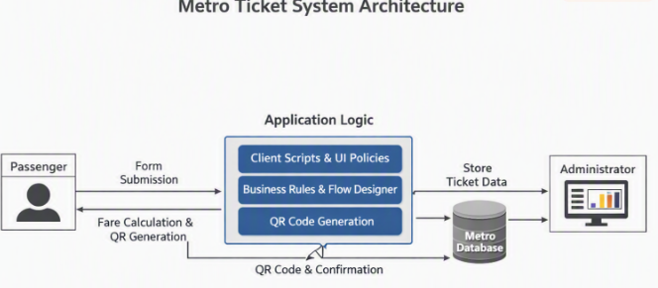

Cloud‑based Deployment: Entire solution hosted on the ServiceNow cloud platform for scalability and reliability.

Dynamic Form Behavior: Catalog Client Scripts and UI Policies ensure real‑time validation and automated fare calculation.

Automated Ticket Processing: Business Rules and Flow Designer handle ticket creation, fare computation, and QR code generation.

Secure Data Management: Ticket and transaction details stored in ServiceNow tables with role‑based ACLs.

Digital Ticketing Proof: QR code generated via API and displayed in the Service Portal widget for station verification.

Table‑1: Components & Technologies

S.No | Component | Description | Technology
1. | User Interface | Interface where passengers enter journey details and view QR ticket | ServiceNow Service Portal, Service Catalog, HTML, CSS, JavaScript
2. | Application Logic‑1 | Handles form behavior, field validation, conditional fields, dynamic inputs | ServiceNow Catalog Client Scripts, UI Policies, JavaScript
3. | Application Logic‑2 | Ticket processing and automated fare calculation | ServiceNow Business Rules, Flow Designer
4. | Application Logic‑3 | QR code generation and display | ServiceNow scripting, Service Portal Widget, QR Server API
5. | Database | Stores ticket, route/fare, booking, and payment details | ServiceNow Platform Database / Custom Tables
6. | Cloud Platform | Managed cloud storage for application records | ServiceNow Cloud Platform
7. | File Storage | No separate file storage required for core ticketing | Not Applicable
8. | External API‑1 | Generates QR code image from ticket/request identifier | QR Server API
9. | External API‑2 | No additional external API required | Not Applicable
10. | Machine Learning Mode | Not used in current implementation | Not Applicable
11. | Infrastructure | Hosts application, database, Service Portal, Catalog, automation services | ServiceNow Cloud Platform

Table‑2: Application Characteristics

S.No | Characteristics | Description | Technology
1. | Framework Usage | No external frameworks;ServiceNow provides platform + scripting environment | ServiceNow Platform, JavaScript
2. | Security Implementations | Role‑based ACLs restrict access; authentication ensures secure transactions | ServiceNow ACLs, Roles, HTTPS
3 | Scalable Architecture | Separation of UI logic, server logic, and data storage supports growth | Separation of UI logic, server logic, and data storage supports growth
4. | Availability | Hosted on ServiceNow cloud; accessible via Service Portal 24/7 | ServiceNow Cloud Platform
5. | Performance | Client-side validation reduces unnecessary server requests, while fare calculation and ticket processing are handled efficiently | JavaScript, Catalog Client Scripts, Business Rules, Flow Designer

